Installing cordova
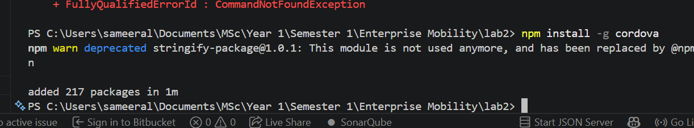
Figure 1: Installing Cordova
Figure 2: Verifying the Installation of Cordova

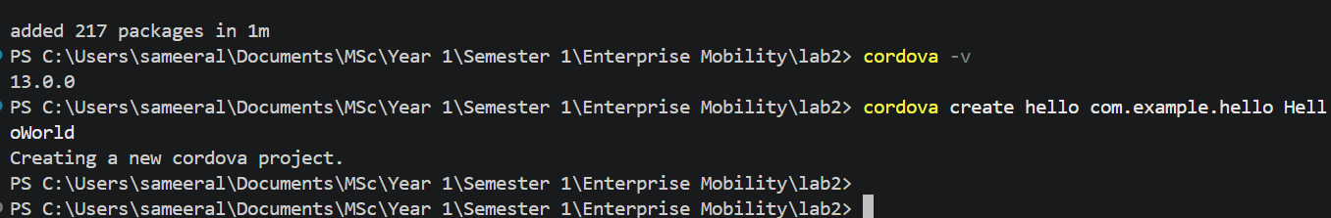
Figure 3: Creating new Cordova project
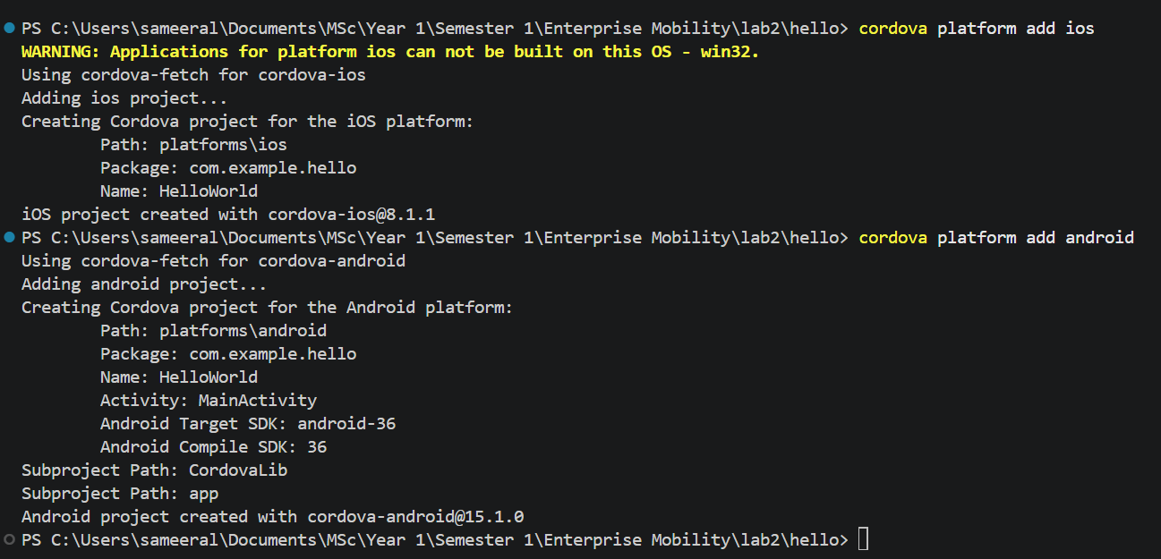
Figure 4: Adding platforms for the target Application

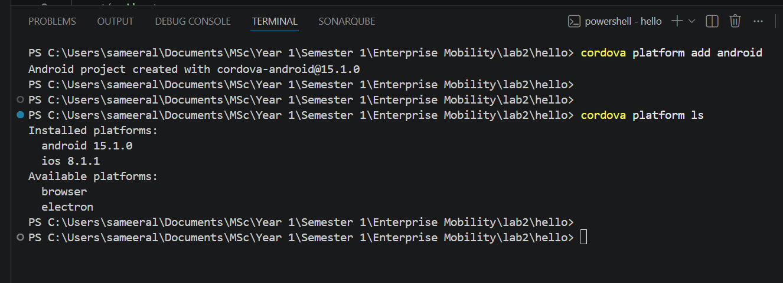
Figure 5: Listing current platforms
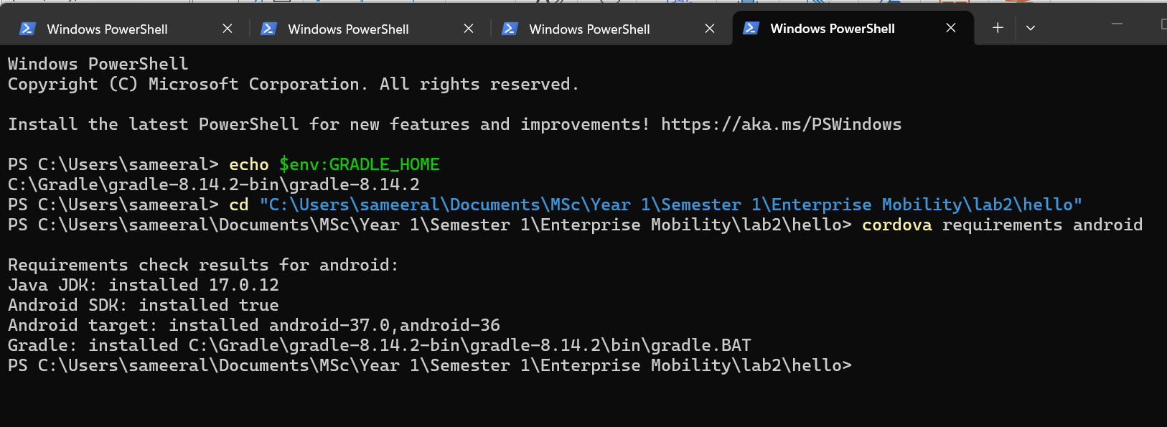
Figure 6: Checking requirements
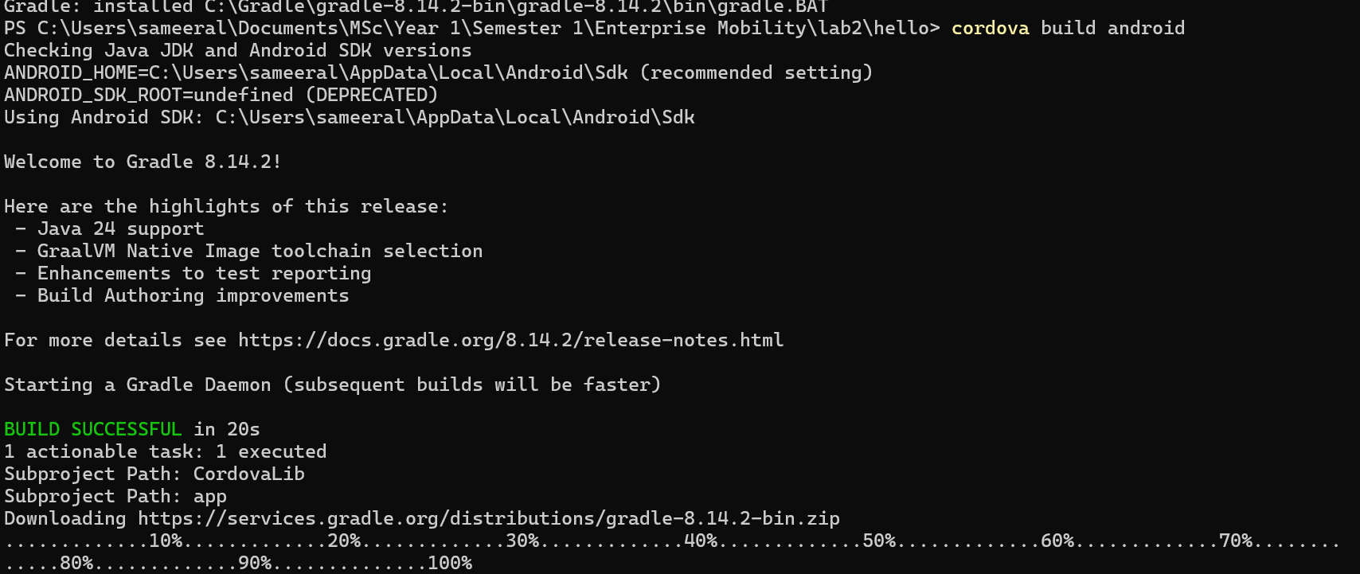
Figure 7: Build Cordova application – 1
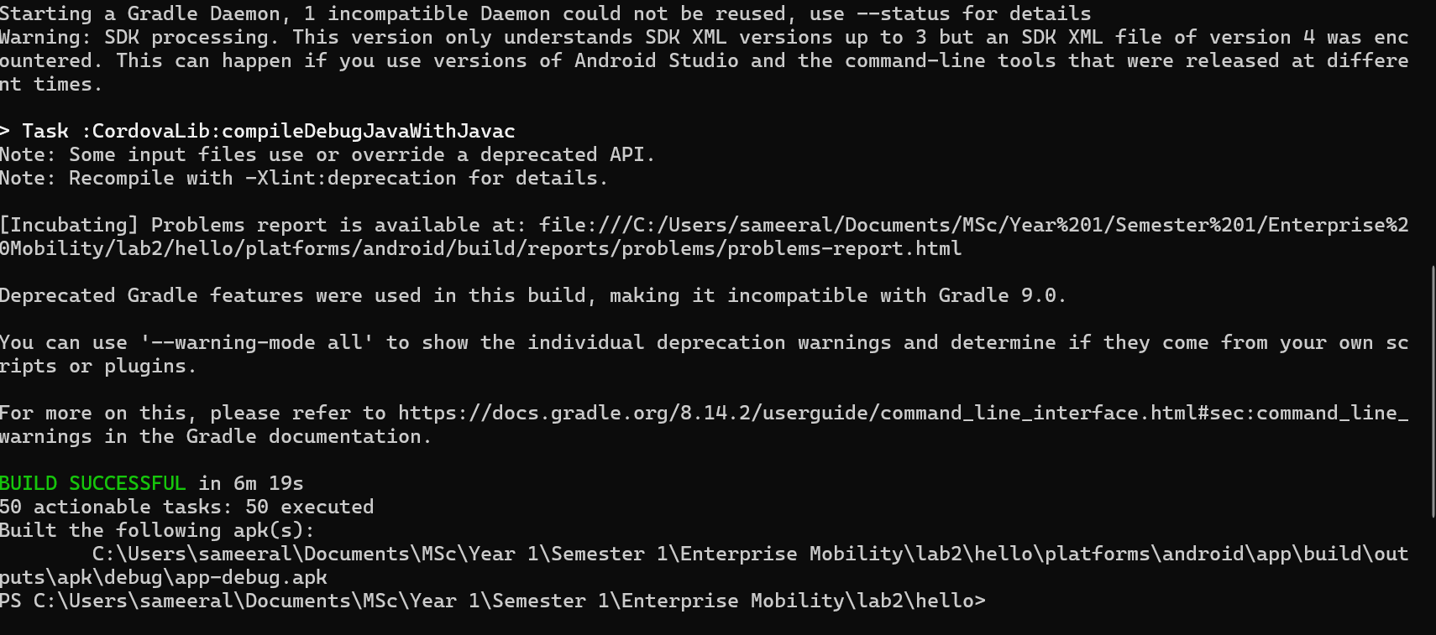
Figure 8: Build Cordova application – 2

